CPSC 473 - Front-End Engineering - Spring 2018

**Rate My Band User Guide**

By Swapnil Katkar, Kelly Nguyen, Snehal Maske, Aditi Patil, Scott Tran, Bernard Do

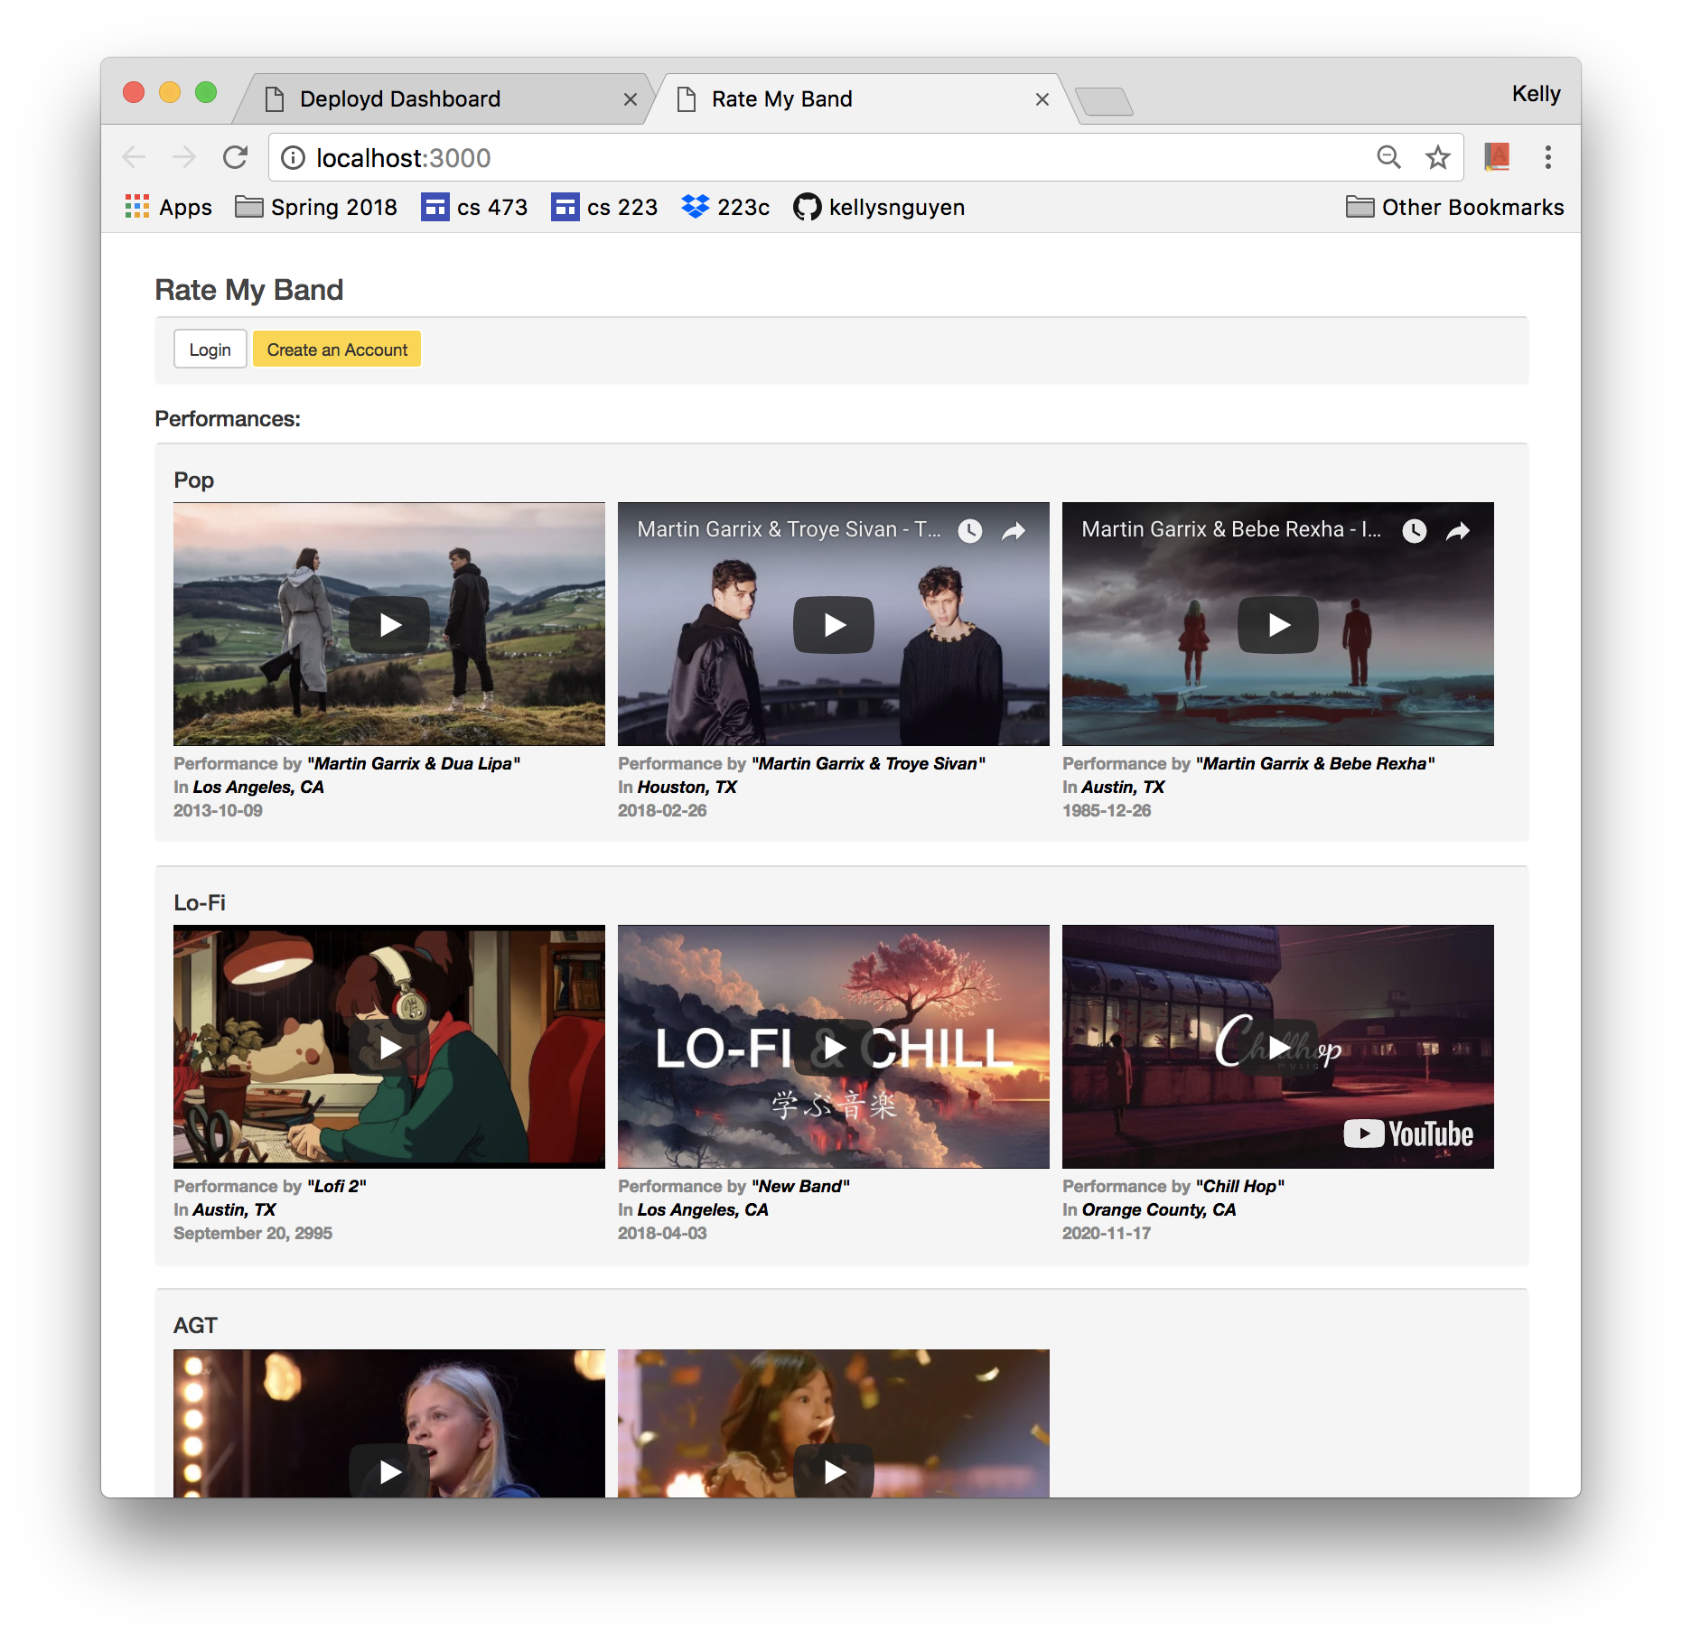

**Introduction**

Welcome to Rate My Band! This guide is intended to help the user navigate the Rate My Band web application and describe some of its features.

Table of Contents

|  |  |
| --- | --- |
| 1. Navigating Rate My Band  a. Home Page  b. Comments Page | 3 |
| 2. Creating an Account | 5 |
| 3. Login and Logout of Existing Accounts | 7 |
| 4. Uploading a Video | 10 |
| 5. Description of Backend Collections  a. USERS  b. USER-COMMENTS  c. VIDEOS | 11 |
| 6. Appendix  a. Embedded Videos | 14 |

**1. Rate My Band Front Page**

a. Home Page

Welcome to the front page of Rate My Band. Uploaded videos are displayed here. The videos are organized according to their genre. Clicking on the video caption brings up the comments page.

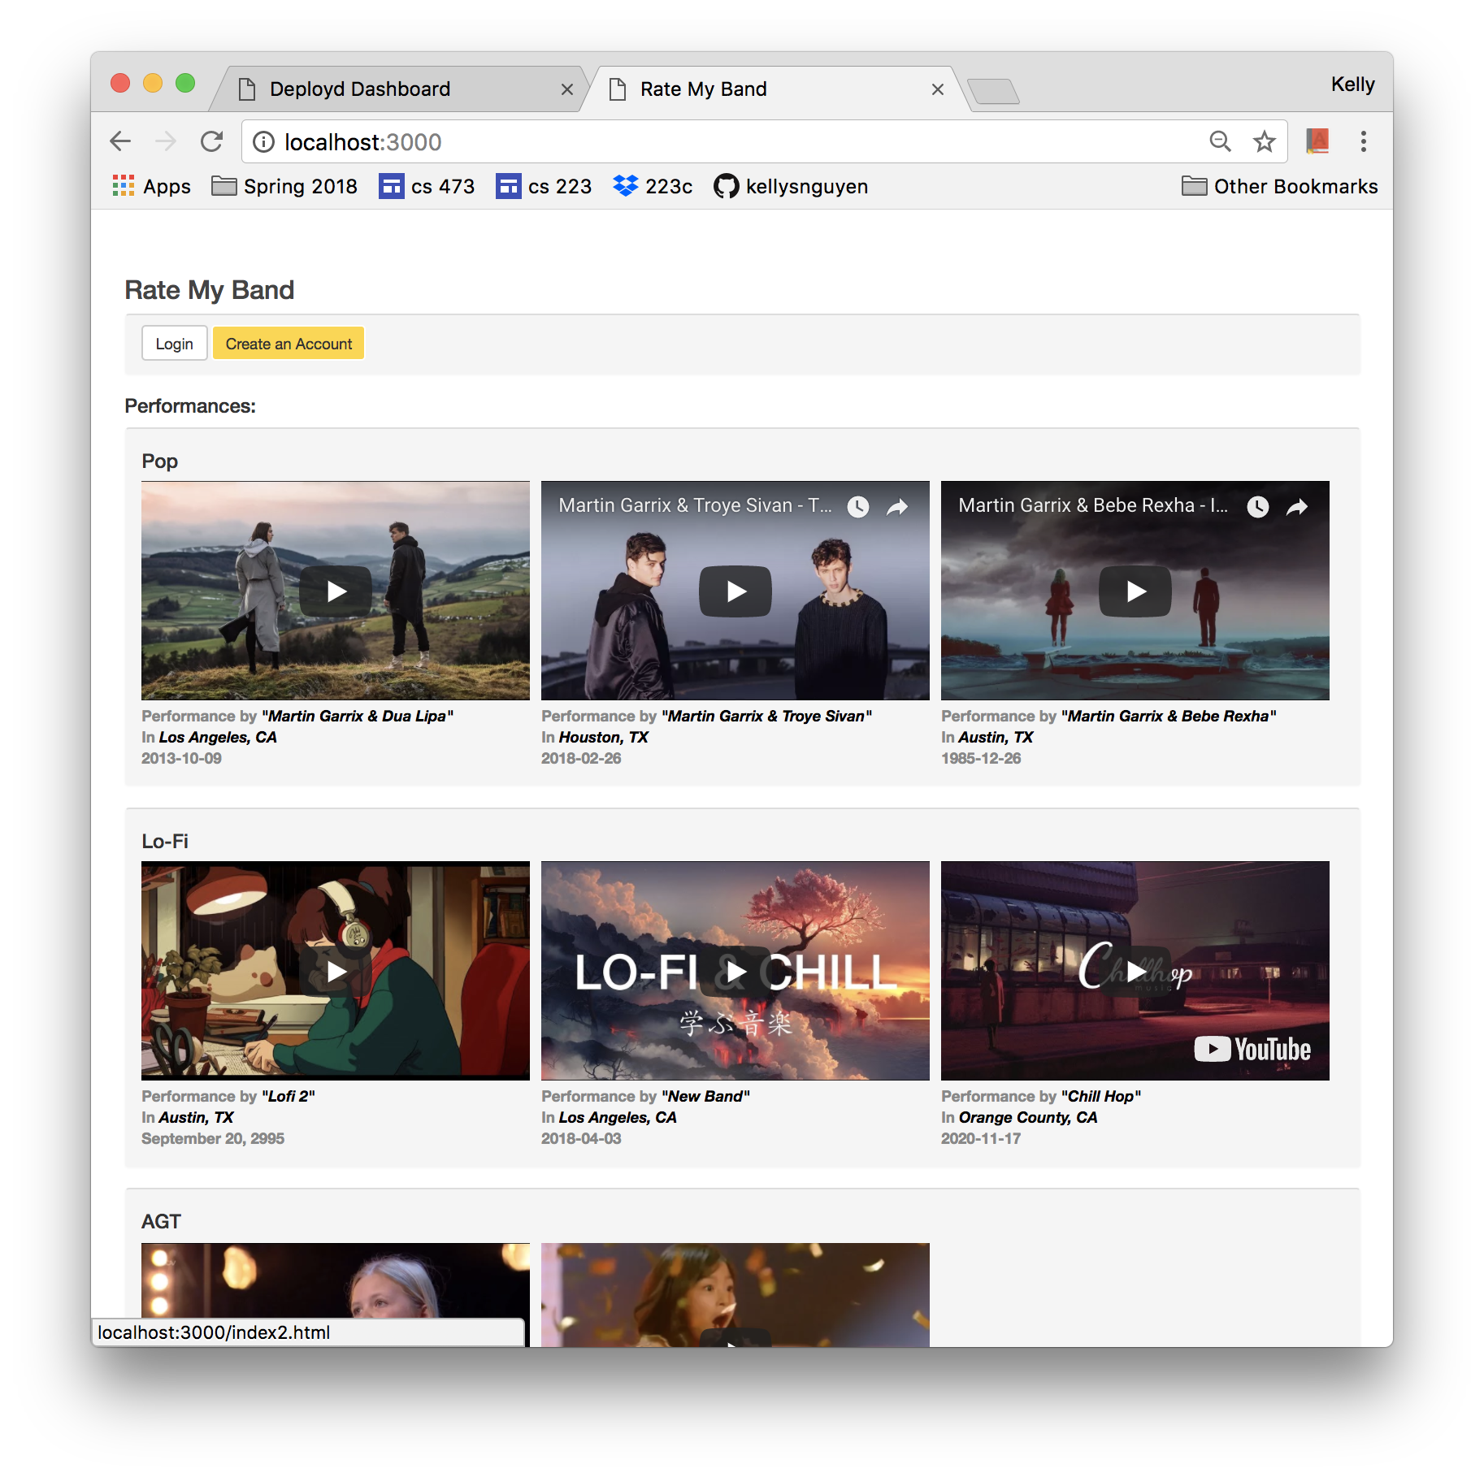

b. Comments Page

The comments page displays the video that was clicked on the home page. Under the video, the user can submit votes and comments. The current vote count corresponding to that video is displayed under the video, and the comments corresponding to that video is displayed under the comment form. The band name, as well as the location and date of the performance are displayed above the video.

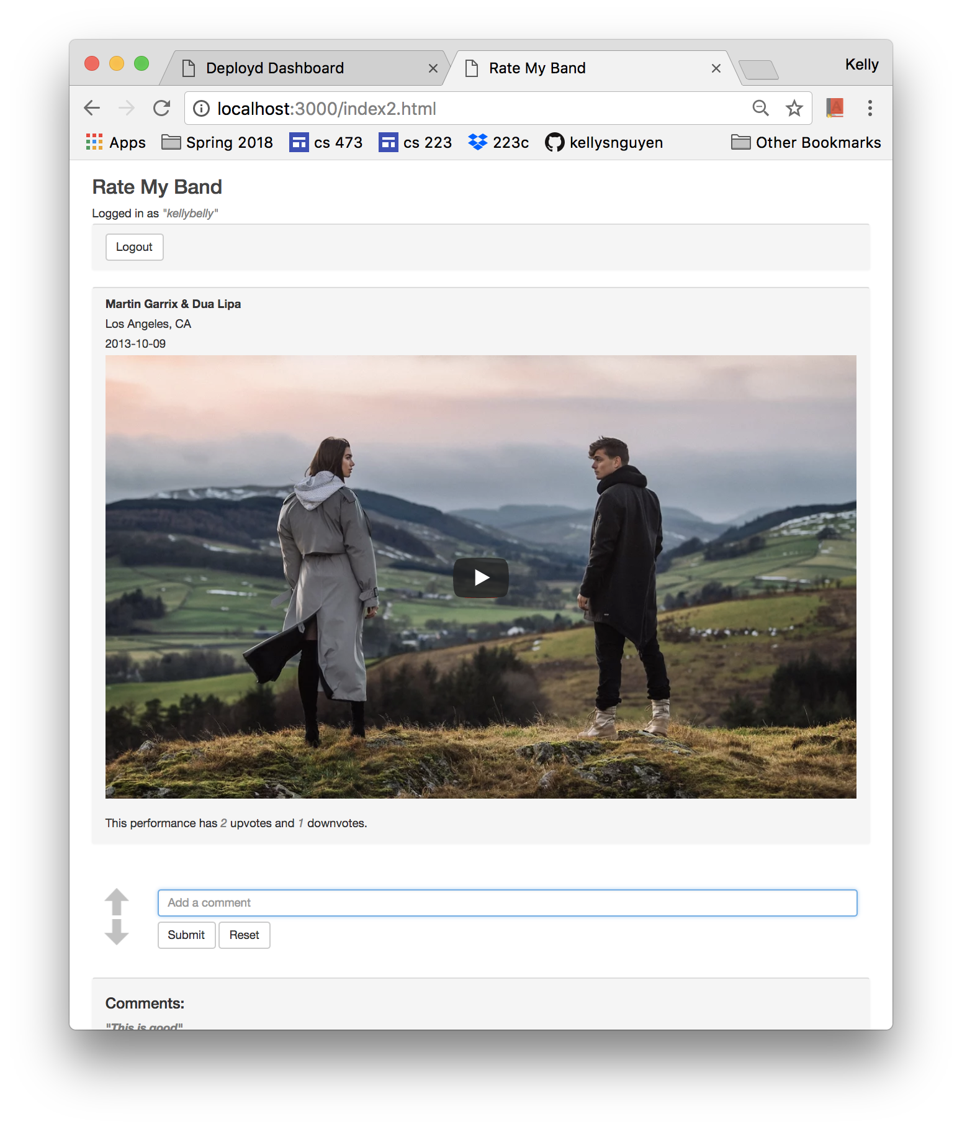

**2. Creating an Account**

a. Click on the yellow “Create an Account” button in order to create a new user account.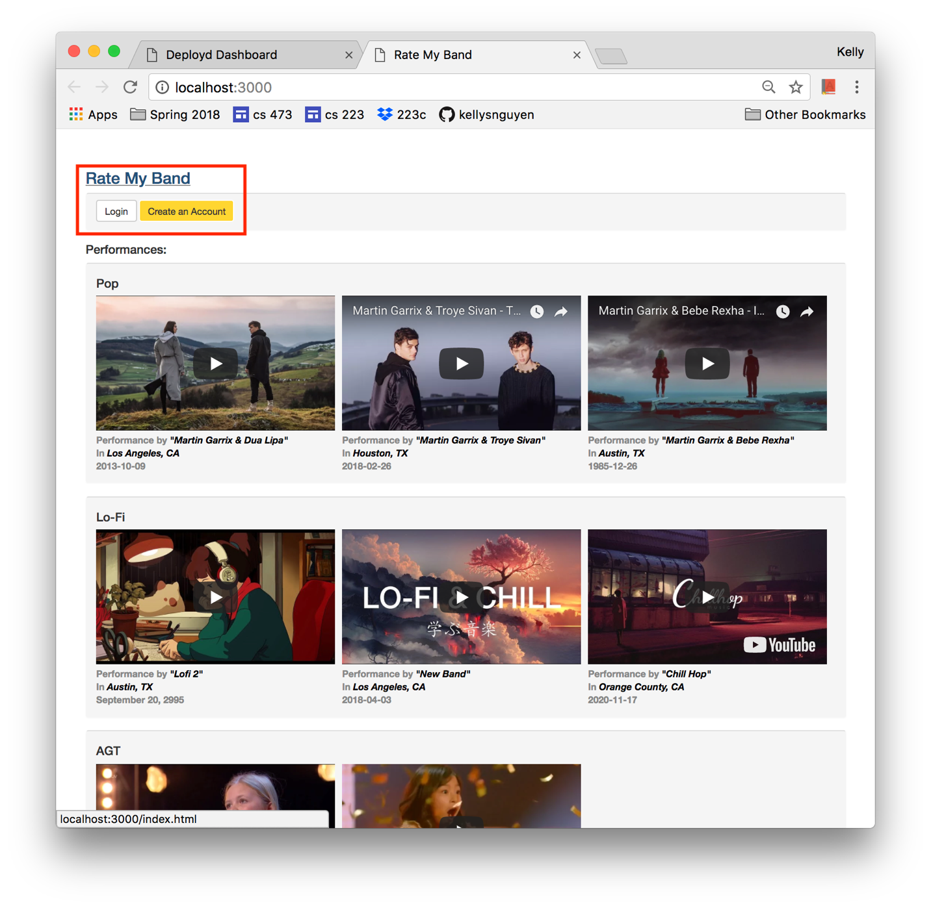

b. In the modal, enter a username and password for the account. Then, click “Sign Up”. 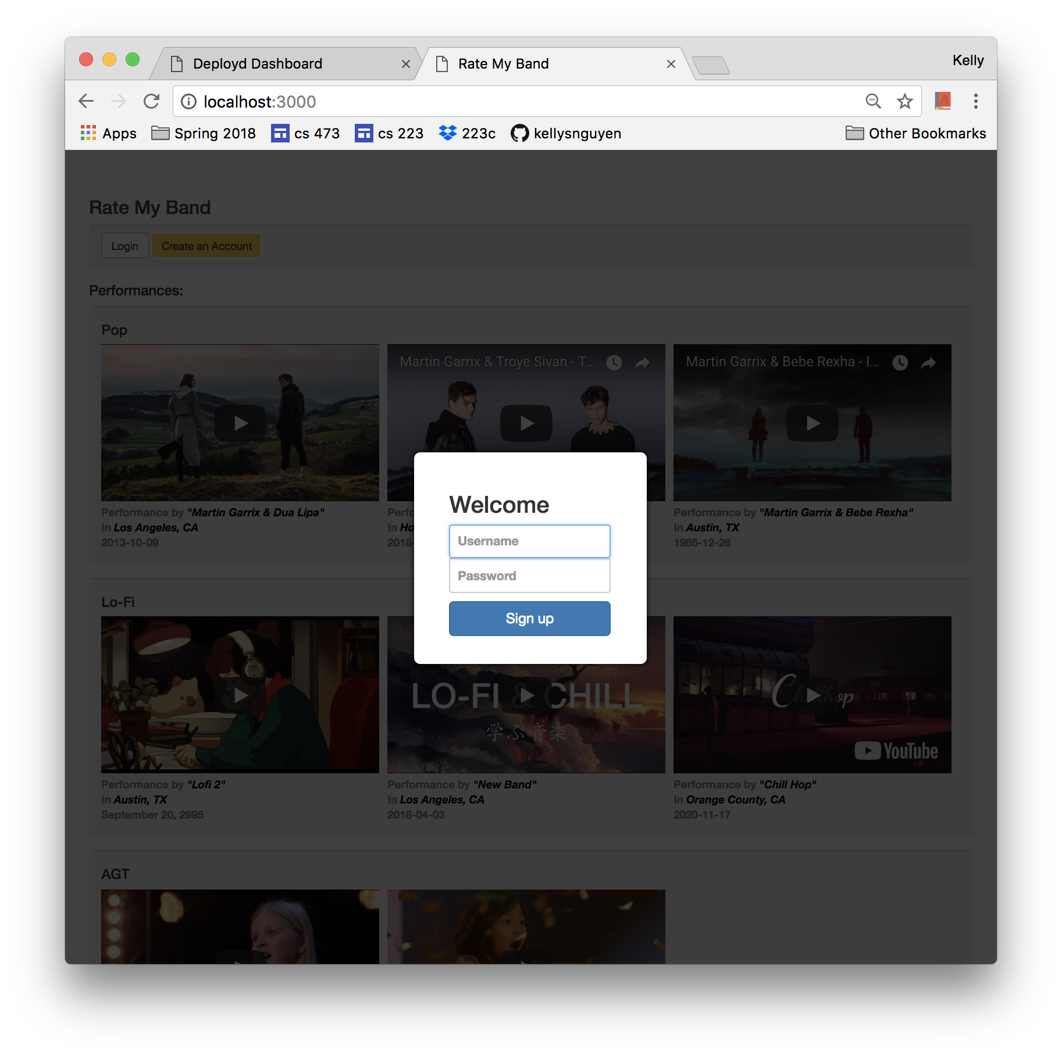

After signing up, users are automatically logged in to the new account.

**3. Login and Logout of Existing Accounts**

a. On the home page, click the “Login” button. You will be prompted by a modal for your login credentials.

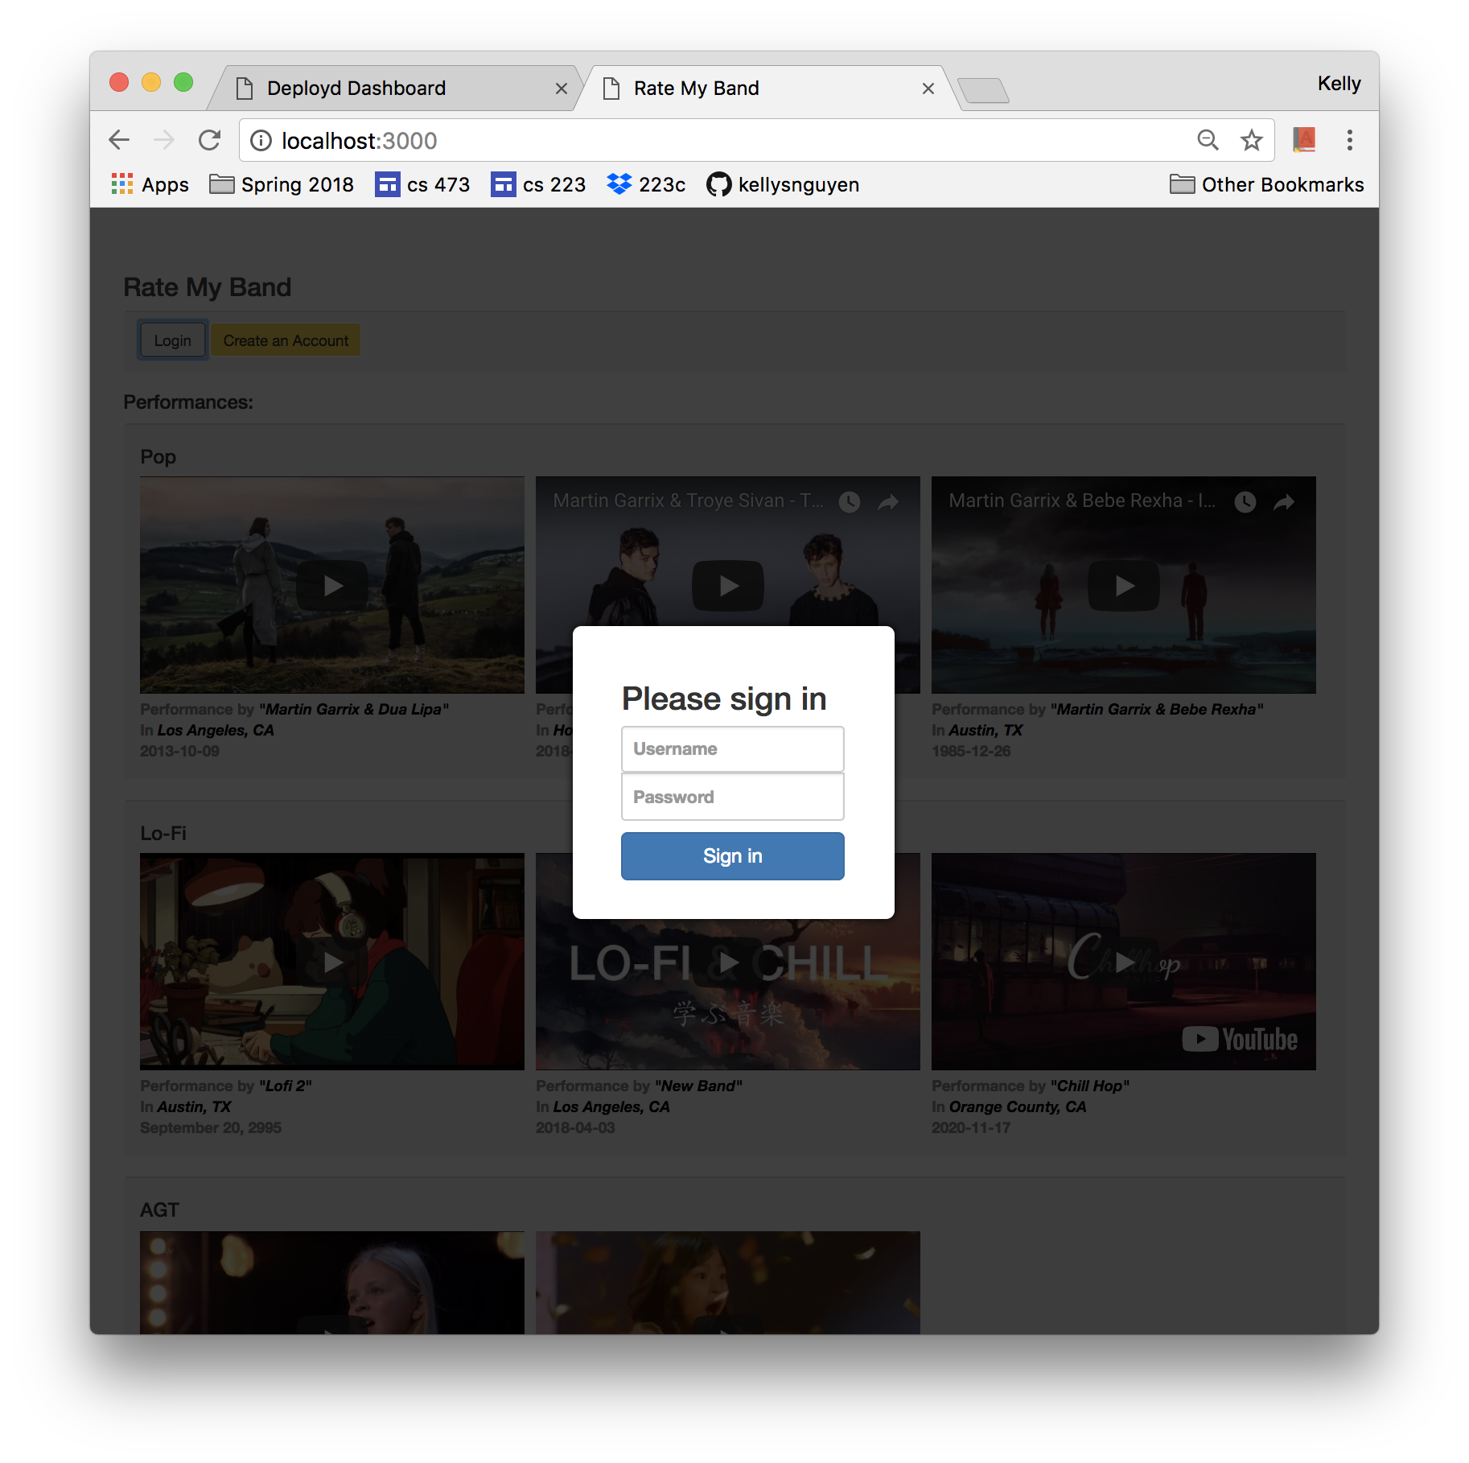

b. If your credentials do not match the ones in the database, an error message will appear. 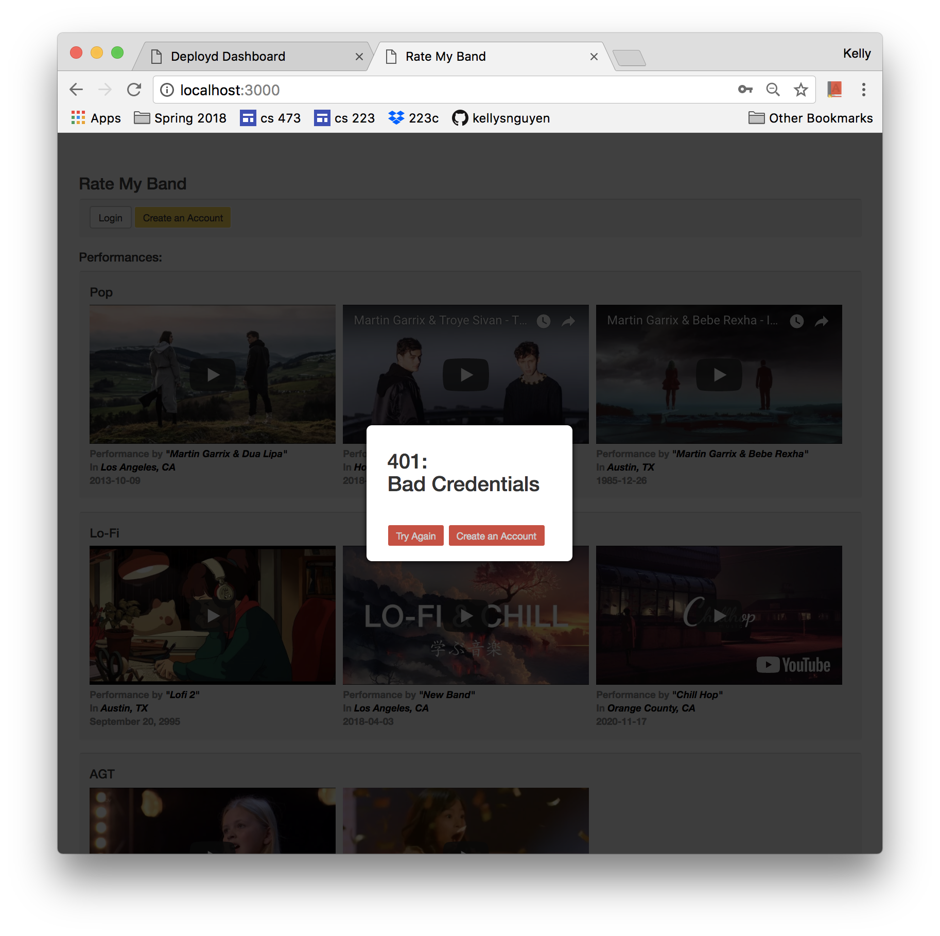

c. On a successful login, your username will appear under the Rate My Band header, and the “Signup” and “Login” buttons will disappear. Two new buttons will appear: “Logout” and “Upload”

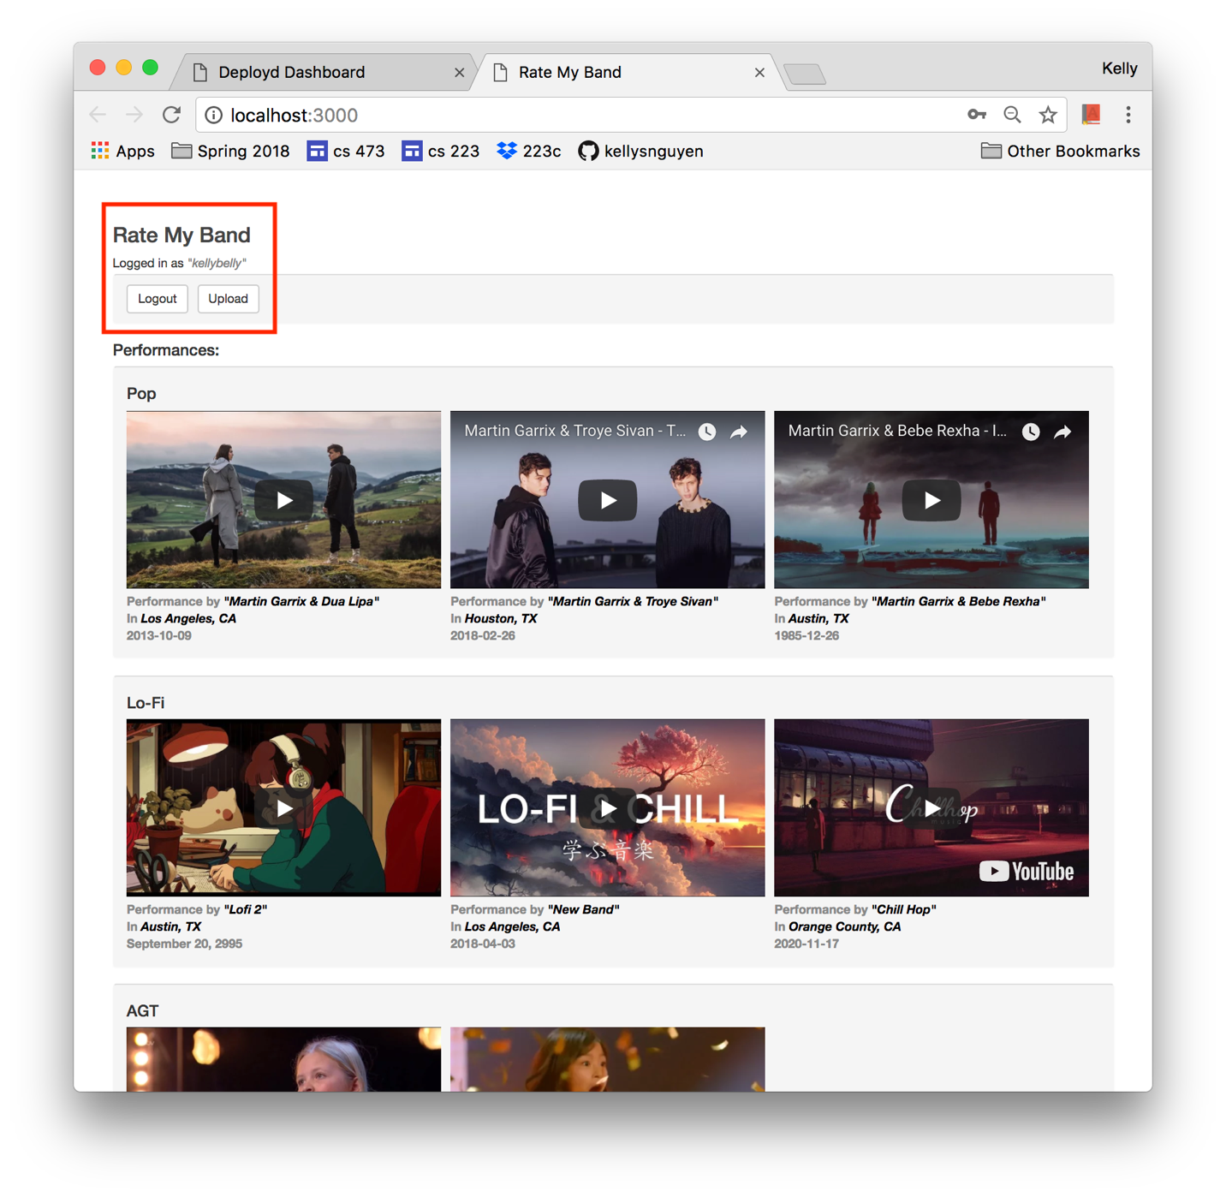

d. Upon logging out, the user will be navigated back to the Rate My Band homepage. The “Sign In” and “Sign Up” buttons will replace the “Logout” and “Upload” buttons.

**4. Uploading a Video Performance**

a. Click the “Upload” button on the home page or the comments page of Rate My Band in order to open up the upload modal.

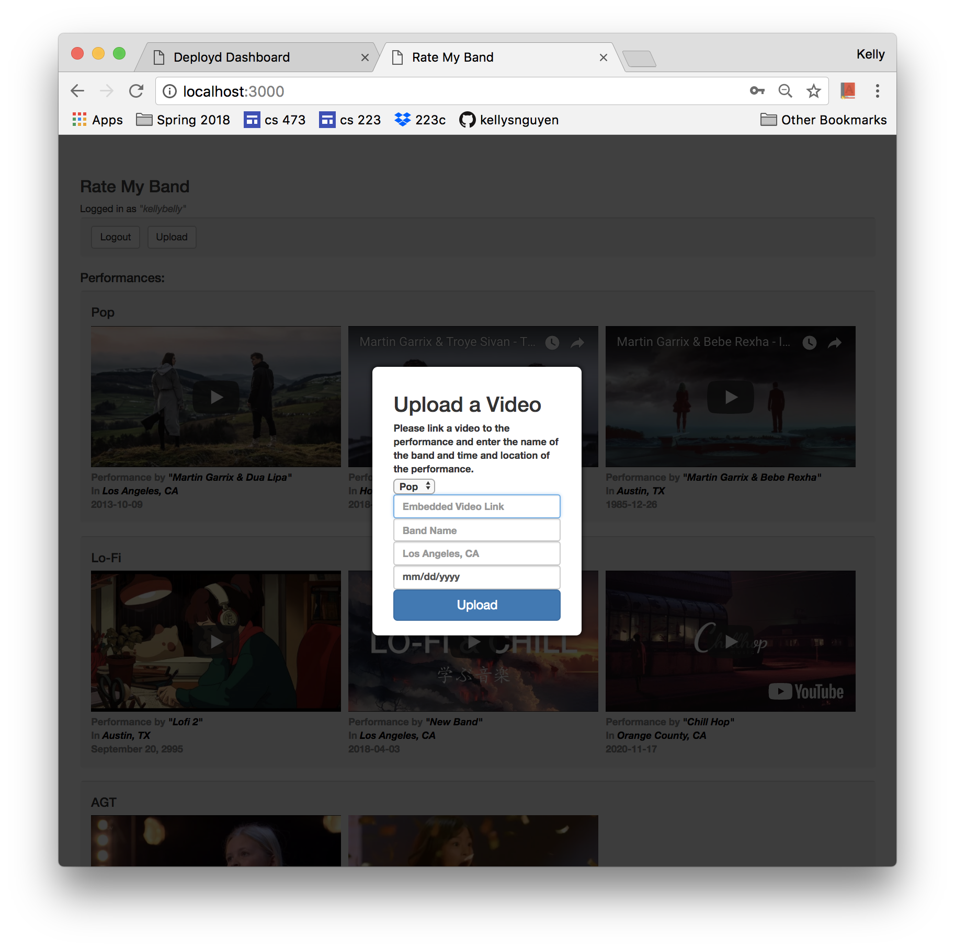

**5. The Rate My Band Backend**

Let’s begin by connecting our application to a backend. Rate My Band requires a backend with the following collections: USER-COMMENTS, USERS, and VIDEOS.

a. The USERS Collection contains all the user accounts for Rate My Band.

Attributes of the USERS Collection:

i. id  
The id attribute is a unique descriptor for the user.

ii. username  
The username attribute is used to login, along with the corresponding password.

iii. password  
The password attribute is used to login, along with the username attribute.

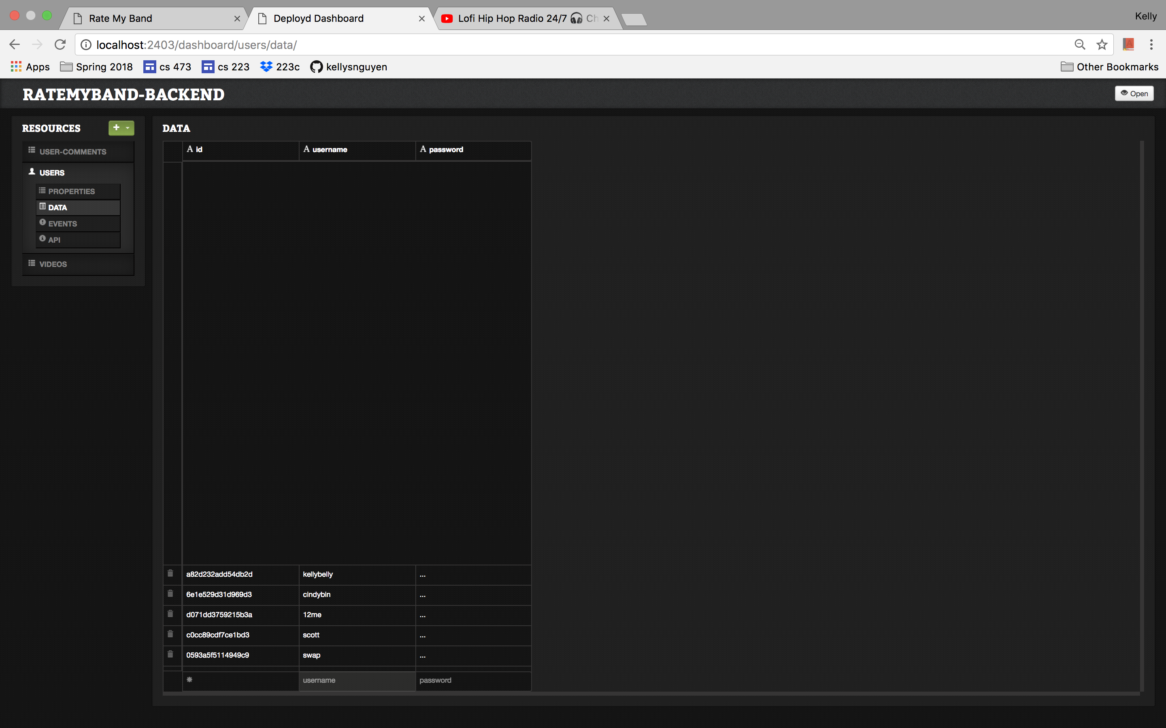

b. The USER-COMMENTS collection holds all the user comments for all the videos.

Attributes of the USER-COMMENTS collection:

i. id

The id is a unique identifier for the comment

ii. username

The username attribute describes the user that submitted the comment. It is used to display the comment on the Rate My Band comments page.

iii. comment

The comment attribute holds the comment data. It is used to display the comment on the Rate My Band comments page.

iv. vote

The vote attribute holds the user’s vote that is accepted along with the comment. It is used to calculate the total vote count for that video on the Rate My Band comments page.

v. videoId

The videoId attribute is used to match the comment to its video

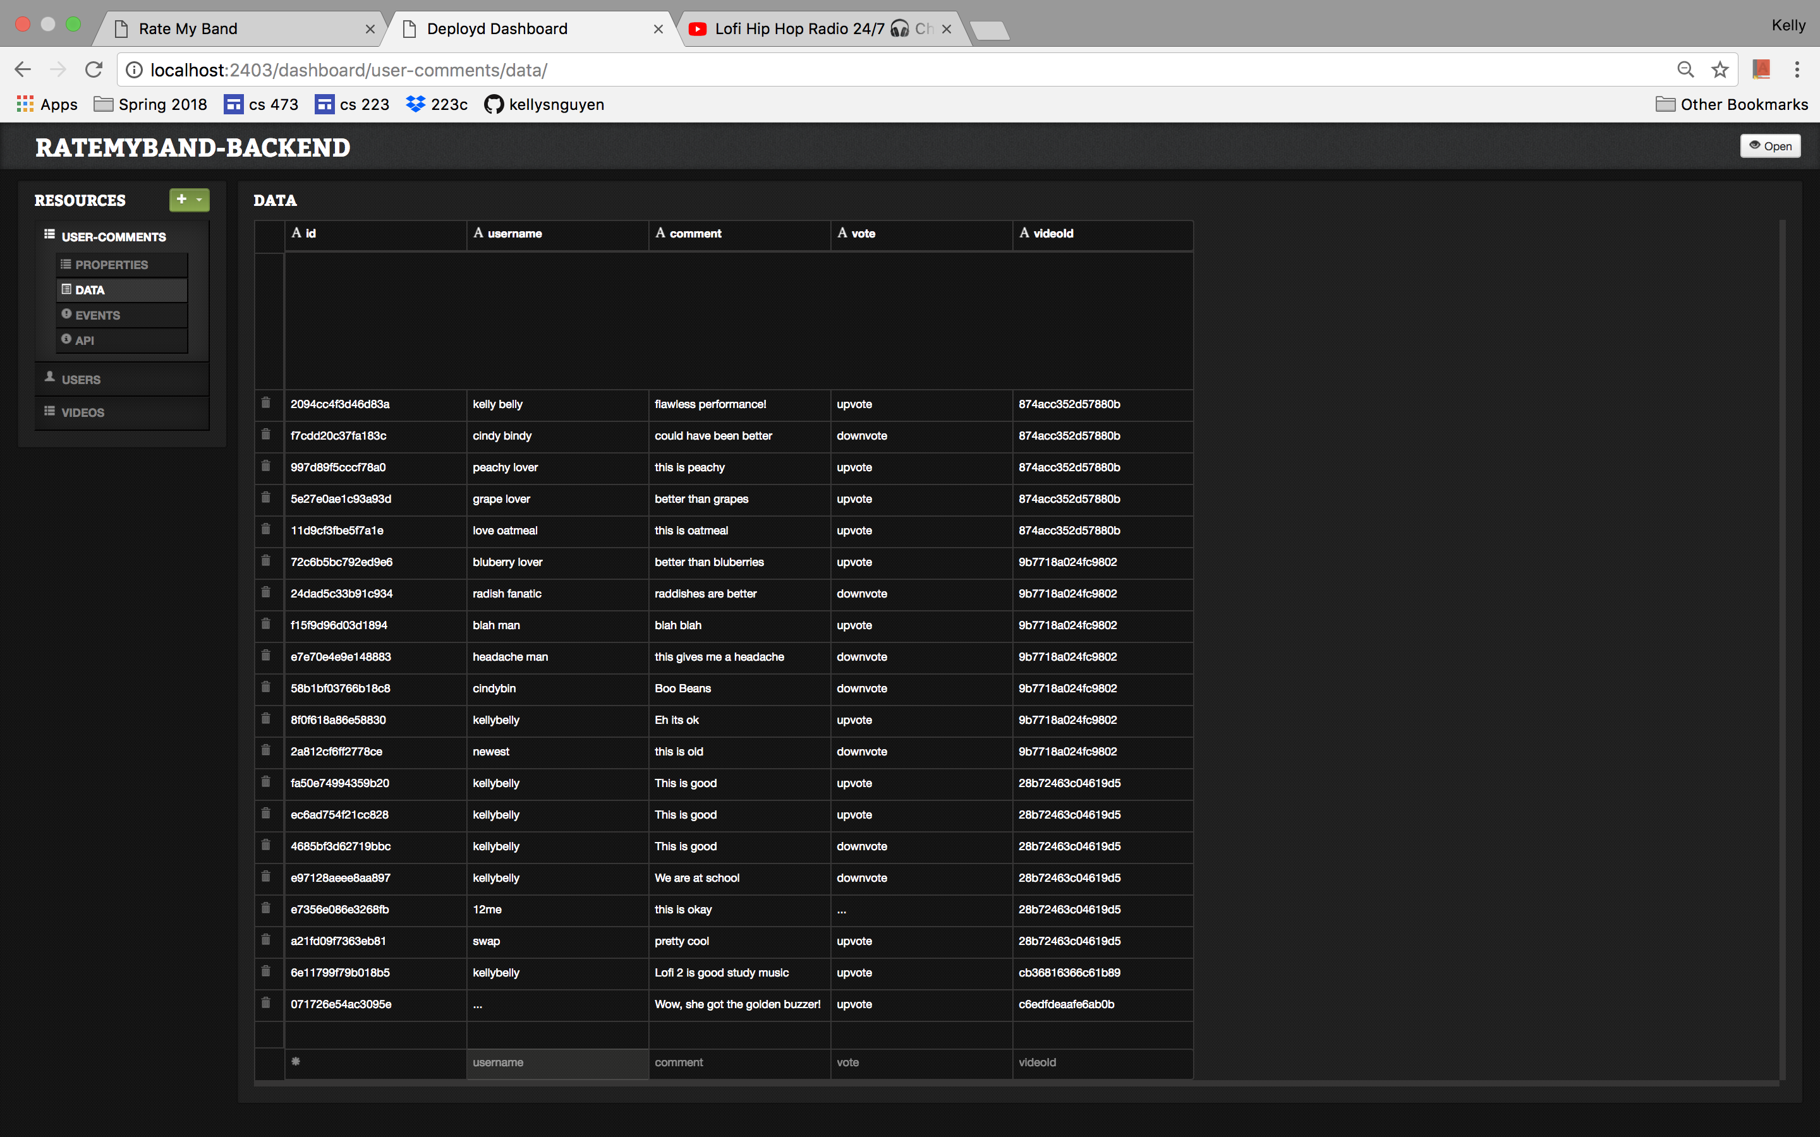

c. The VIDEOS collection holds all the videos uploaded by users.

Attributes of VIDEOS collection:

i. id  
The id attribute is used by the Rate My Band comments page to display the video, video comments, band name, and performance location corresponding to the video that the user clicked on the home page.

ii. videoLink  
The videoLink attribute is the embedded link. The user needs to generate this link. Instructions on one way to do this are in section 4a.

iii. bandName  
The bandName attribute describes the name of the band in the video.

iv. performanceDate  
The performanceDate attribute describes the date of the performance.

v. performanceLocation  
The performanceLocation attribute describes the location of the performance.

vi. genre  
The genre attribute is used to sort the video on the Rate My Band home page.

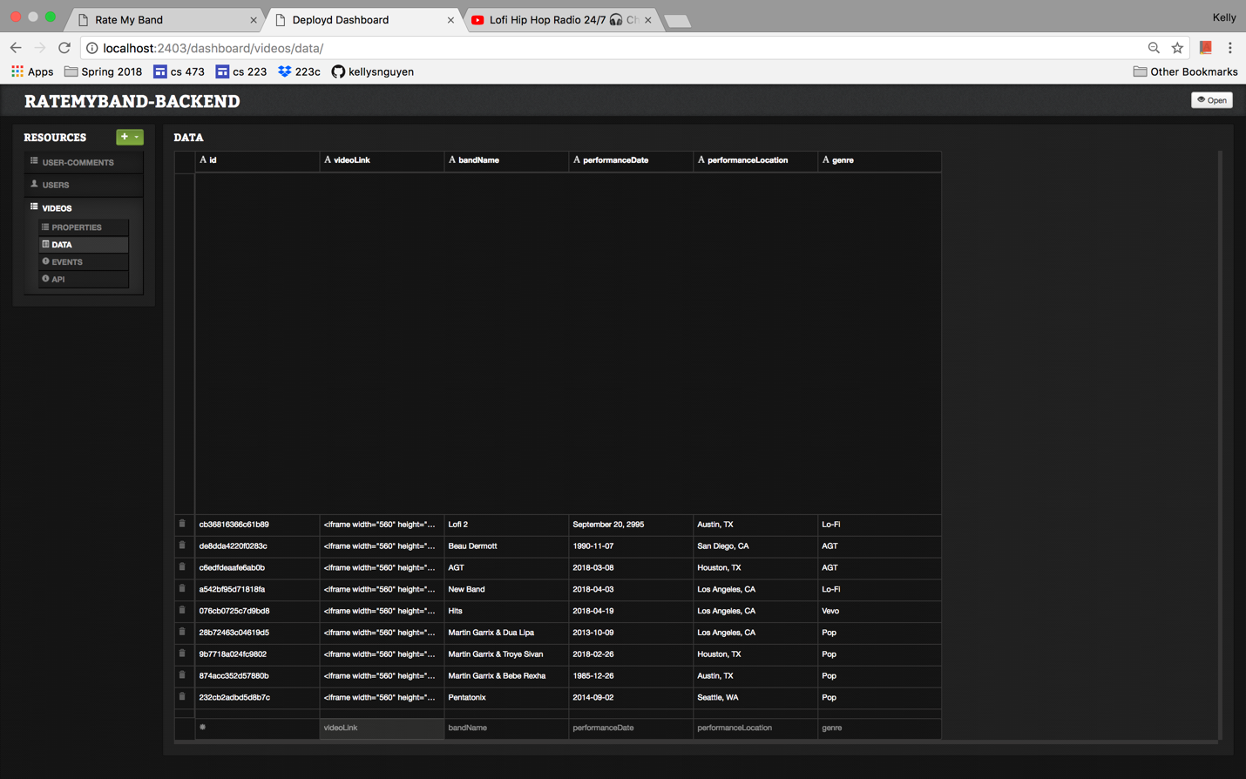

**6. Appendix**

a. Embedded Videos

The upload form requires an embedded video link. There are many ways to create an embedded video link. This guide covers how to obtain one from youtube.com

The embedded link is highlighted below. Copy and paste this link into the video link section of the upload form.

